**Practical 2**

Aim: Design suitable database for Library Management System.

**LibCreate.java**

import java.sql.*;

public class LibCreate {

// JDBC driver name and database URL

static final String JDBC_DRIVER = "com.mysql.jdbc.Driver"; static final String DB_URL = "jdbc:mysql://localhost/STUDENTS";

// Database credentials

static final String USER = "username";

static final String PASS = "password";

public static void main(String[] args) {

Connection conn = null;

Statement stmt = null;

try{

//STEP 2: Register JDBC driver

Class.forName("com.mysql.jdbc.Driver");

//STEP 3: Open a connection

System.out.println("Connecting to a selected database..."); conn = DriverManager.getConnection(DB_URL, USER, PASS); System.out.println("Connected database successfully...");

//STEP 4: Execute a query

System.out.println("Creating table in given database..."); stmt = conn.createStatement();

String sql = "CREATE TABLE Librarian " +

"(id INTEGER not NULL, " +

" name VARCHAR(255), " +

"password VARCHAR(255), " +

"email VARCHAR(255), " +

"adderss VARCHAR(255), " +

"city VARCHAR(255), " +

"contact VARCHAR(255), " +

" PRIMARY KEY ( id ))";

stmt.executeUpdate(sql);

System.out.println("Created table in given database...");

}catch(SQLException se){

//Handle errors for JDBC

se.printStackTrace();

}catch(Exception e){

//Handle errors for Class.forName

e.printStackTrace();

}finally{

//finally block used to close resources

try{

if(stmt!=null)

conn.close();

}catch(SQLException se){

}// do nothing

try{

if(conn!=null)

conn.close();

}catch(SQLException se){

se.printStackTrace();

}//end finally try

}//end try

System.out.println("Goodbye!");

}//end main

}//end LibCreate

**Output**

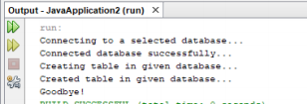

**In a similar manner we can create the tables for books table thus completing the database structure**

**Practical 3a: Registration**

import java.sql.Connection;

import java.sql.DriverManager;

import java.sql.ResultSet;

import java.sql.SQLException;

import java.sql.Statement;

import java.util.logging.Level;

import java.util.logging.Logger;

import javax.swing.JOptionPane;

/*

* To change this license header, choose License Headers in Project Properties.

* To change this template file, choose Tools | Templates

* and open the template in the editor.

*/

/**

*

* @author bot

*/

public class pract2A extends javax.swing.JFrame {

/**

* Creates new form pract2A

*/

public pract2A() {

initComponents();

}

/**

* This method is called from within the constructor to initialize the form.

* WARNING: Do NOT modify this code. The content of this method is always

* regenerated by the Form Editor.

*/

@SuppressWarnings("unchecked")

// <editor-fold defaultstate="collapsed" desc="Generated Code">

private void initComponents() {

jLabel1 = new javax.swing.JLabel();

jLabel2 = new javax.swing.JLabel();

jLabel3 = new javax.swing.JLabel();

jTextField1 = new javax.swing.JTextField();

jTextField2 = new javax.swing.JTextField();

jTextField3 = new javax.swing.JTextField();

jButton1 = new javax.swing.JButton();

setDefaultCloseOperation(javax.swing.WindowConstants.EXIT_ON_CLOSE);

jLabel1.setText("Username");

jLabel2.setText("Password");

jLabel3.setText("Mobile no");

jButton1.setText("Register");

jButton1.addActionListener(new java.awt.event.ActionListener() {

public void actionPerformed(java.awt.event.ActionEvent evt) {

jButton1ActionPerformed(evt);

}

});

javax.swing.GroupLayout layout = new javax.swing.GroupLayout(getContentPane());

getContentPane().setLayout(layout);

layout.setHorizontalGroup(

layout.createParallelGroup(javax.swing.GroupLayout.Alignment.LEADING)

.addGroup(javax.swing.GroupLayout.Alignment.TRAILING, layout.createSequentialGroup()

.addContainerGap(104, Short.MAX_VALUE)

.addGroup(layout.createParallelGroup(javax.swing.GroupLayout.Alignment.LEADING)

.addGroup(layout.createSequentialGroup()

.addGroup(layout.createParallelGroup(javax.swing.GroupLayout.Alignment.LEADING)

.addComponent(jLabel1)

.addComponent(jLabel2)

.addComponent(jLabel3))

.addGap(51, 51, 51)

.addGroup(layout.createParallelGroup(javax.swing.GroupLayout.Alignment.LEADING, false)

.addComponent(jTextField3)

.addComponent(jTextField2)

.addComponent(jTextField1, javax.swing.GroupLayout.PREFERRED_SIZE, 100, javax.swing.GroupLayout.PREFERRED_SIZE)))

.addGroup(javax.swing.GroupLayout.Alignment.TRAILING, layout.createSequentialGroup()

.addPreferredGap(javax.swing.LayoutStyle.ComponentPlacement.RELATED, 56, javax.swing.GroupLayout.PREFERRED_SIZE)

.addComponent(jButton1)

.addGap(76, 76, 76)))

.addGap(86, 86, 86))

);

layout.setVerticalGroup(

layout.createParallelGroup(javax.swing.GroupLayout.Alignment.LEADING)

.addGroup(layout.createSequentialGroup()

.addGap(70, 70, 70)

.addGroup(layout.createParallelGroup(javax.swing.GroupLayout.Alignment.BASELINE)

.addComponent(jLabel1)

.addComponent(jTextField1, javax.swing.GroupLayout.PREFERRED_SIZE, javax.swing.GroupLayout.DEFAULT_SIZE, javax.swing.GroupLayout.PREFERRED_SIZE))

.addGap(18, 18, 18)

.addGroup(layout.createParallelGroup(javax.swing.GroupLayout.Alignment.BASELINE)

.addComponent(jLabel2)

.addComponent(jTextField2, javax.swing.GroupLayout.PREFERRED_SIZE, javax.swing.GroupLayout.DEFAULT_SIZE, javax.swing.GroupLayout.PREFERRED_SIZE))

.addGap(18, 18, 18)

.addGroup(layout.createParallelGroup(javax.swing.GroupLayout.Alignment.BASELINE)

.addComponent(jLabel3)

.addComponent(jTextField3, javax.swing.GroupLayout.PREFERRED_SIZE, javax.swing.GroupLayout.DEFAULT_SIZE, javax.swing.GroupLayout.PREFERRED_SIZE))

.addGap(18, 18, 18)

.addComponent(jButton1)

.addContainerGap(72, Short.MAX_VALUE))

);

pack();

}// </editor-fold>

private void jButton1ActionPerformed(java.awt.event.ActionEvent evt) {

// TODO add your handling code here:

try {

String uname= jTextField1.getText();

String pass= jTextField2.getText();

String mobileno= jTextField3.getText();

Integer maxid = 0;

Connection conn=DriverManager.getConnection("jdbc:mysql://localhost:3306/loginform?autoReconnect=true&useSSL=false", "root", "root");

Statement stmt =conn.createStatement();

String sql= "select max(id) from myrecord";

ResultSet result=stmt.executeQuery(sql);

if(result.next()){

maxid = result.getInt(1);

//JOptionPane.showMessageDialog(this,String.valueOf(maxid));

maxid+=1;

}

sql="insert into myrecord values("+ maxid +",'"

+uname+"','"+pass+"','"+mobileno+"');";

stmt.executeUpdate(sql);

JOptionPane.showMessageDialog(this, "registered");

} catch (SQLException ex) {

Logger.getLogger(pract2A.class.getName()).log(Level.SEVERE, null, ex);

}

}

/**

* @param args the command line arguments

*/

public static void main(String args[]) {

/* Set the Nimbus look and feel */

//<editor-fold defaultstate="collapsed" desc=" Look and feel setting code (optional) ">

/* If Nimbus (introduced in Java SE 6) is not available, stay with the default look and feel.

* For details see http://download.oracle.com/javase/tutorial/uiswing/lookandfeel/plaf.html

*/

try {

for (javax.swing.UIManager.LookAndFeelInfo info : javax.swing.UIManager.getInstalledLookAndFeels()) {

if ("Nimbus".equals(info.getName())) {

javax.swing.UIManager.setLookAndFeel(info.getClassName());

break;

}

}

} catch (ClassNotFoundException ex) {

java.util.logging.Logger.getLogger(pract2A.class.getName()).log(java.util.logging.Level.SEVERE, null, ex);

} catch (InstantiationException ex) {

java.util.logging.Logger.getLogger(pract2A.class.getName()).log(java.util.logging.Level.SEVERE, null, ex);

} catch (IllegalAccessException ex) {

java.util.logging.Logger.getLogger(pract2A.class.getName()).log(java.util.logging.Level.SEVERE, null, ex);

} catch (javax.swing.UnsupportedLookAndFeelException ex) {

java.util.logging.Logger.getLogger(pract2A.class.getName()).log(java.util.logging.Level.SEVERE, null, ex);

}

//</editor-fold>

/* Create and display the form */

java.awt.EventQueue.invokeLater(new Runnable() {

public void run() {

new pract2A().setVisible(true);

}

});

}

// Variables declaration - do not modify

private javax.swing.JButton jButton1;

private javax.swing.JLabel jLabel1;

private javax.swing.JLabel jLabel2;

private javax.swing.JLabel jLabel3;

private javax.swing.JTextField jTextField1;

private javax.swing.JTextField jTextField2;

private javax.swing.JTextField jTextField3;

// End of variables declaration

}

**Output:**

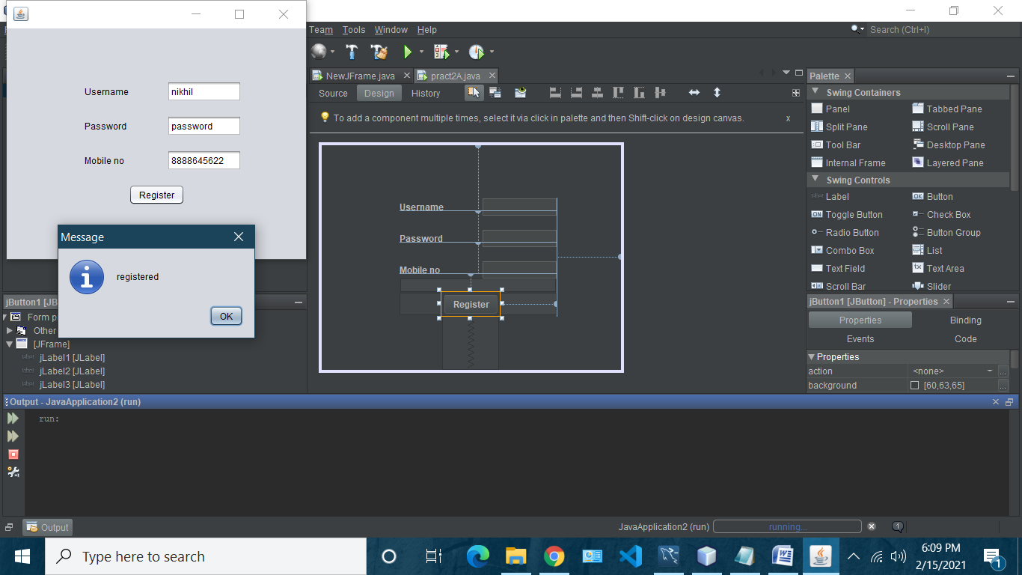

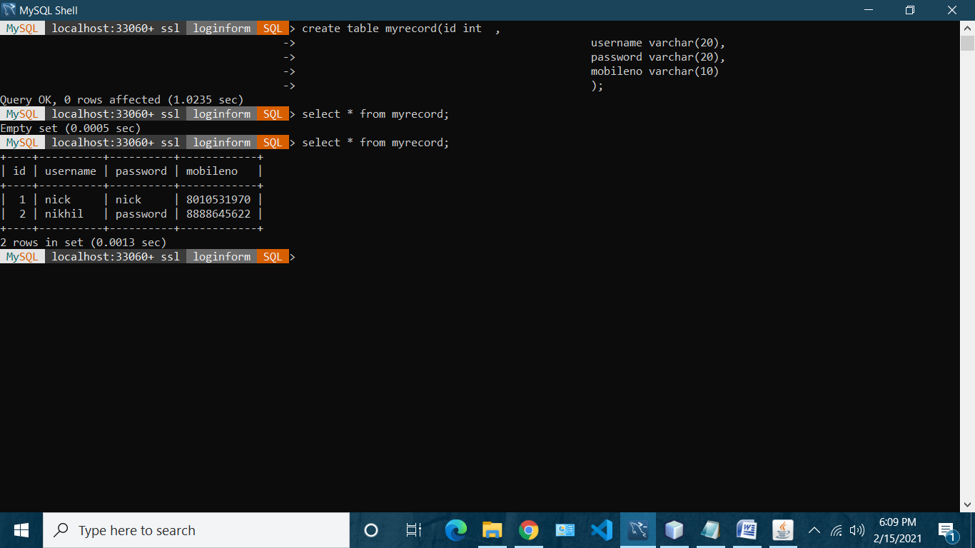

**Practical 3b: login**

import java.sql.Connection;

import java.sql.DriverManager;

import java.sql.ResultSet;

import java.sql.SQLException;

import java.sql.Statement;

import java.util.logging.Level;

import java.util.logging.Logger;

import javax.swing.JOptionPane;

/*

* To change this license header, choose License Headers in Project Properties.

* To change this template file, choose Tools | Templates

* and open the template in the editor.

*/

/**

*

* @author bot

*/

public class NewJFrame extends javax.swing.JFrame {

/**

* Creates new form NewJFrame

*/

public NewJFrame() {

initComponents();

}

/**

* This method is called from within the constructor to initialize the form.

* WARNING: Do NOT modify this code. The content of this method is always

* regenerated by the Form Editor.

*/

@SuppressWarnings("unchecked")

// <editor-fold defaultstate="collapsed" desc="Generated Code">

private void initComponents() {

jTextField1 = new javax.swing.JTextField();

jLabel1 = new javax.swing.JLabel();

jLabel2 = new javax.swing.JLabel();

jButton1 = new javax.swing.JButton();

jPasswordField1 = new javax.swing.JPasswordField();

setDefaultCloseOperation(javax.swing.WindowConstants.EXIT_ON_CLOSE);

jLabel1.setText("Username");

jLabel2.setText("Password");

jButton1.setText("submit");

jButton1.addActionListener(new java.awt.event.ActionListener() {

public void actionPerformed(java.awt.event.ActionEvent evt) {

jButton1ActionPerformed(evt);

}

});

jPasswordField1.setText("jPasswordField1");

javax.swing.GroupLayout layout = new javax.swing.GroupLayout(getContentPane());

getContentPane().setLayout(layout);

layout.setHorizontalGroup(

layout.createParallelGroup(javax.swing.GroupLayout.Alignment.LEADING)

.addGroup(layout.createSequentialGroup()

.addGroup(layout.createParallelGroup(javax.swing.GroupLayout.Alignment.LEADING)

.addGroup(layout.createSequentialGroup()

.addGap(96, 96, 96)

.addGroup(layout.createParallelGroup(javax.swing.GroupLayout.Alignment.LEADING)

.addComponent(jLabel1)

.addComponent(jLabel2))

.addGap(41, 41, 41)

.addGroup(layout.createParallelGroup(javax.swing.GroupLayout.Alignment.LEADING, false)

.addComponent(jTextField1, javax.swing.GroupLayout.DEFAULT_SIZE, 74, Short.MAX_VALUE)

.addComponent(jPasswordField1, javax.swing.GroupLayout.PREFERRED_SIZE, 1, Short.MAX_VALUE)))

.addGroup(layout.createSequentialGroup()

.addGap(149, 149, 149)

.addComponent(jButton1)))

.addContainerGap(73, Short.MAX_VALUE))

);

layout.setVerticalGroup(

layout.createParallelGroup(javax.swing.GroupLayout.Alignment.LEADING)

.addGroup(layout.createSequentialGroup()

.addGap(102, 102, 102)

.addGroup(layout.createParallelGroup(javax.swing.GroupLayout.Alignment.BASELINE)

.addComponent(jTextField1, javax.swing.GroupLayout.PREFERRED_SIZE, javax.swing.GroupLayout.DEFAULT_SIZE, javax.swing.GroupLayout.PREFERRED_SIZE)

.addComponent(jLabel1))

.addGap(18, 18, 18)

.addGroup(layout.createParallelGroup(javax.swing.GroupLayout.Alignment.BASELINE)

.addComponent(jLabel2)

.addComponent(jPasswordField1, javax.swing.GroupLayout.PREFERRED_SIZE, javax.swing.GroupLayout.DEFAULT_SIZE, javax.swing.GroupLayout.PREFERRED_SIZE))

.addGap(18, 18, 18)

.addComponent(jButton1)

.addContainerGap(101, Short.MAX_VALUE))

);

pack();

}// </editor-fold>

private void jButton1ActionPerformed(java.awt.event.ActionEvent evt) {

// TODO add your handling code here:

String uname=jTextField1.getText();

String pass;

pass = String.valueOf(jPasswordField1.getPassword());

//JOptionPane.showMessageDialog(this, pass);

try {

Connection con =DriverManager.getConnection("jdbc:mysql://localhost:3306/loginform?autoReconnect=true&useSSL=false","root","root");

Statement stmt=con.createStatement();

String sql="select * from myrecord where username='"+uname+"' and password='"+pass+"';";

//JOptionPane.showMessageDialog(this, sql);

ResultSet r=stmt.executeQuery(sql);

if(r.next())

{JOptionPane.showMessageDialog(this, "sucess");}

else

{{JOptionPane.showMessageDialog(this, "unsucess");}}

} catch (SQLException ex) {

Logger.getLogger(NewJFrame.class.getName()).log(Level.SEVERE, null, ex);

}

}

/**

* @param args the command line arguments

*/

public static void main(String args[]) {

/* Set the Nimbus look and feel */

//<editor-fold defaultstate="collapsed" desc=" Look and feel setting code (optional) ">

/* If Nimbus (introduced in Java SE 6) is not available, stay with the default look and feel.

* For details see http://download.oracle.com/javase/tutorial/uiswing/lookandfeel/plaf.html

*/

try {

for (javax.swing.UIManager.LookAndFeelInfo info : javax.swing.UIManager.getInstalledLookAndFeels()) {

if ("Nimbus".equals(info.getName())) {

javax.swing.UIManager.setLookAndFeel(info.getClassName());

break;

}

}

} catch (ClassNotFoundException ex) {

java.util.logging.Logger.getLogger(NewJFrame.class.getName()).log(java.util.logging.Level.SEVERE, null, ex);

} catch (InstantiationException ex) {

java.util.logging.Logger.getLogger(NewJFrame.class.getName()).log(java.util.logging.Level.SEVERE, null, ex);

} catch (IllegalAccessException ex) {

java.util.logging.Logger.getLogger(NewJFrame.class.getName()).log(java.util.logging.Level.SEVERE, null, ex);

} catch (javax.swing.UnsupportedLookAndFeelException ex) {

java.util.logging.Logger.getLogger(NewJFrame.class.getName()).log(java.util.logging.Level.SEVERE, null, ex);

}

//</editor-fold>

/* Create and display the form */

java.awt.EventQueue.invokeLater(new Runnable() {

public void run() {

new NewJFrame().setVisible(true);

}

});

}

// Variables declaration - do not modify

private javax.swing.JButton jButton1;

private javax.swing.JLabel jLabel1;

private javax.swing.JLabel jLabel2;

private javax.swing.JPasswordField jPasswordField1;

private javax.swing.JTextField jTextField1;

// End of variables declaration

}

Output:

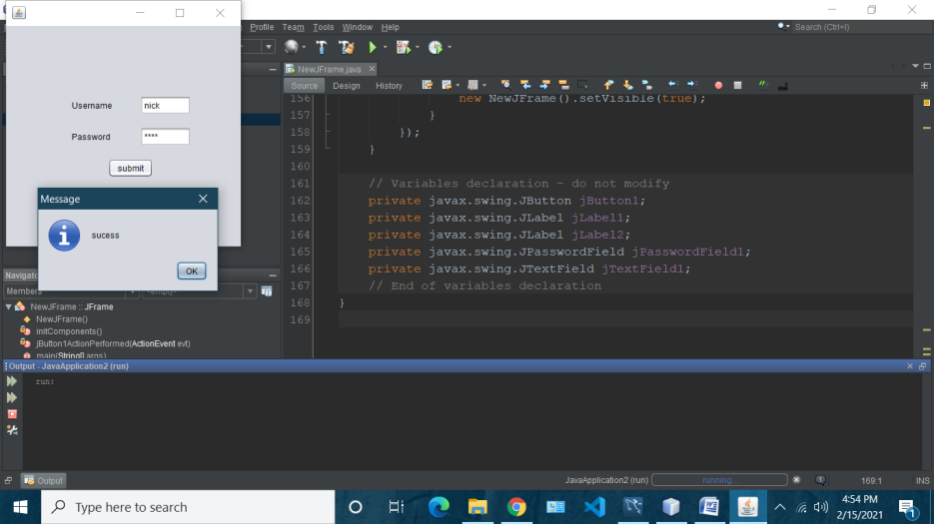

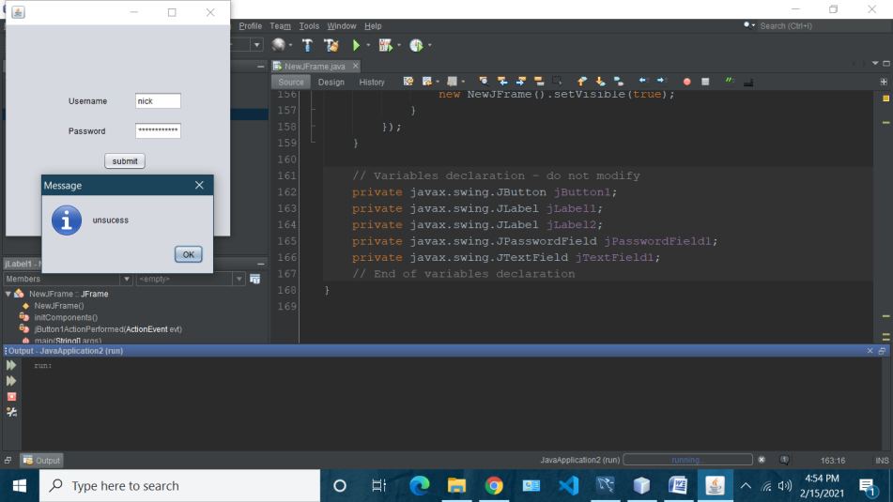

**Practical 3C: Change Password**

import java.sql.Connection;

import java.sql.DriverManager;

import java.sql.ResultSet;

import java.sql.SQLException;

import java.sql.Statement;

import java.util.logging.Level;

import java.util.logging.Logger;

import javax.swing.JOptionPane;

/*

* To change this license header, choose License Headers in Project Properties.

* To change this template file, choose Tools | Templates

* and open the template in the editor.

*/

/**

*

* @author bot

*/

public class chgpass extends javax.swing.JFrame {

/**

* Creates new form chgpass

*/

public chgpass() {

initComponents();

}

/**

* This method is called from within the constructor to initialize the form.

* WARNING: Do NOT modify this code. The content of this method is always

* regenerated by the Form Editor.

*/

@SuppressWarnings("unchecked")

// <editor-fold defaultstate="collapsed" desc="Generated Code">

private void initComponents() {

jLabel1 = new javax.swing.JLabel();

jLabel2 = new javax.swing.JLabel();

jLabel3 = new javax.swing.JLabel();

jLabel4 = new javax.swing.JLabel();

jTextField1 = new javax.swing.JTextField();

jTextField3 = new javax.swing.JTextField();

jButton1 = new javax.swing.JButton();

jPasswordField1 = new javax.swing.JPasswordField();

jPasswordField2 = new javax.swing.JPasswordField();

setDefaultCloseOperation(javax.swing.WindowConstants.EXIT_ON_CLOSE);

jLabel1.setText("Usernme");

jLabel2.setText("Old Password");

jLabel3.setText("Mobile no");

jLabel4.setText("New Password");

jTextField1.addActionListener(new java.awt.event.ActionListener() {

public void actionPerformed(java.awt.event.ActionEvent evt) {

jTextField1ActionPerformed(evt);

}

});

jButton1.setText("Update Password");

jButton1.addActionListener(new java.awt.event.ActionListener() {

public void actionPerformed(java.awt.event.ActionEvent evt) {

jButton1ActionPerformed(evt);

}

});

jPasswordField1.setText("jPasswordField1");

jPasswordField2.setText("jPasswordField2");

javax.swing.GroupLayout layout = new javax.swing.GroupLayout(getContentPane());

getContentPane().setLayout(layout);

layout.setHorizontalGroup(

layout.createParallelGroup(javax.swing.GroupLayout.Alignment.LEADING)

.addGroup(layout.createSequentialGroup()

.addGroup(layout.createParallelGroup(javax.swing.GroupLayout.Alignment.LEADING)

.addGroup(layout.createSequentialGroup()

.addGap(71, 71, 71)

.addGroup(layout.createParallelGroup(javax.swing.GroupLayout.Alignment.TRAILING)

.addComponent(jLabel4)

.addComponent(jLabel3)

.addComponent(jLabel2)

.addComponent(jLabel1))

.addGap(64, 64, 64)

.addGroup(layout.createParallelGroup(javax.swing.GroupLayout.Alignment.LEADING, false)

.addComponent(jTextField1)

.addComponent(jTextField3)

.addComponent(jPasswordField1, javax.swing.GroupLayout.PREFERRED_SIZE, javax.swing.GroupLayout.DEFAULT_SIZE, javax.swing.GroupLayout.PREFERRED_SIZE)

.addComponent(jPasswordField2, javax.swing.GroupLayout.PREFERRED_SIZE, javax.swing.GroupLayout.DEFAULT_SIZE, javax.swing.GroupLayout.PREFERRED_SIZE)))

.addGroup(layout.createSequentialGroup()

.addGap(134, 134, 134)

.addComponent(jButton1)))

.addContainerGap(60, Short.MAX_VALUE))

);

layout.setVerticalGroup(

layout.createParallelGroup(javax.swing.GroupLayout.Alignment.LEADING)

.addGroup(layout.createSequentialGroup()

.addGap(69, 69, 69)

.addGroup(layout.createParallelGroup(javax.swing.GroupLayout.Alignment.BASELINE)

.addComponent(jTextField1, javax.swing.GroupLayout.PREFERRED_SIZE, javax.swing.GroupLayout.DEFAULT_SIZE, javax.swing.GroupLayout.PREFERRED_SIZE)

.addComponent(jLabel1))

.addGap(29, 29, 29)

.addGroup(layout.createParallelGroup(javax.swing.GroupLayout.Alignment.BASELINE)

.addComponent(jLabel2)

.addComponent(jPasswordField1, javax.swing.GroupLayout.PREFERRED_SIZE, javax.swing.GroupLayout.DEFAULT_SIZE, javax.swing.GroupLayout.PREFERRED_SIZE))

.addGap(18, 18, 18)

.addGroup(layout.createParallelGroup(javax.swing.GroupLayout.Alignment.BASELINE)

.addComponent(jTextField3, javax.swing.GroupLayout.PREFERRED_SIZE, javax.swing.GroupLayout.DEFAULT_SIZE, javax.swing.GroupLayout.PREFERRED_SIZE)

.addComponent(jLabel3))

.addGap(18, 18, 18)

.addGroup(layout.createParallelGroup(javax.swing.GroupLayout.Alignment.LEADING)

.addComponent(jLabel4)

.addComponent(jPasswordField2, javax.swing.GroupLayout.PREFERRED_SIZE, javax.swing.GroupLayout.DEFAULT_SIZE, javax.swing.GroupLayout.PREFERRED_SIZE))

.addGap(18, 18, 18)

.addComponent(jButton1)

.addContainerGap(24, Short.MAX_VALUE))

);

pack();

}// </editor-fold>

private void jTextField1ActionPerformed(java.awt.event.ActionEvent evt) {

// TODO add your handling code here:

}

private void jButton1ActionPerformed(java.awt.event.ActionEvent evt) {

// TODO add your handling code here:

try {

String uname= jTextField1.getText();

String pass= String.valueOf(jPasswordField1.getPassword());

String mobileno= jTextField3.getText();

String newpass= String.valueOf(jPasswordField2.getPassword());

Connection conn=DriverManager.getConnection("jdbc:mysql://localhost:3306/loginform?autoReconnect=true&useSSL=false", "root", "root");

Statement stmt =conn.createStatement();

String sql= "select id from myrecord where username='"+ uname

+ "' and password ='"+pass+"' and mobileno='"+mobileno+"';";

ResultSet result=stmt.executeQuery(sql);

if(result.next()){

sql="update myrecord set password='"+newpass+"' where id='"+result.getInt(1)+"';";

stmt.executeUpdate(sql);

JOptionPane.showMessageDialog(this,"your password has been updated");

}

else{

JOptionPane.showMessageDialog(this,"your credentials do not match");

}

} catch (SQLException ex) {

Logger.getLogger(pract2A.class.getName()).log(Level.SEVERE, null, ex);

}

}

/**

* @param args the command line arguments

*/

public static void main(String args[]) {

/* Set the Nimbus look and feel */

//<editor-fold defaultstate="collapsed" desc=" Look and feel setting code (optional) ">

/* If Nimbus (introduced in Java SE 6) is not available, stay with the default look and feel.

* For details see http://download.oracle.com/javase/tutorial/uiswing/lookandfeel/plaf.html

*/

try {

for (javax.swing.UIManager.LookAndFeelInfo info : javax.swing.UIManager.getInstalledLookAndFeels()) {

if ("Nimbus".equals(info.getName())) {

javax.swing.UIManager.setLookAndFeel(info.getClassName());

break;

}

}

} catch (ClassNotFoundException ex) {

java.util.logging.Logger.getLogger(chgpass.class.getName()).log(java.util.logging.Level.SEVERE, null, ex);

} catch (InstantiationException ex) {

java.util.logging.Logger.getLogger(chgpass.class.getName()).log(java.util.logging.Level.SEVERE, null, ex);

} catch (IllegalAccessException ex) {

java.util.logging.Logger.getLogger(chgpass.class.getName()).log(java.util.logging.Level.SEVERE, null, ex);

} catch (javax.swing.UnsupportedLookAndFeelException ex) {

java.util.logging.Logger.getLogger(chgpass.class.getName()).log(java.util.logging.Level.SEVERE, null, ex);

}

//</editor-fold>

/* Create and display the form */

java.awt.EventQueue.invokeLater(new Runnable() {

public void run() {

new chgpass().setVisible(true);

}

});

}

// Variables declaration - do not modify

private javax.swing.JButton jButton1;

private javax.swing.JLabel jLabel1;

private javax.swing.JLabel jLabel2;

private javax.swing.JLabel jLabel3;

private javax.swing.JLabel jLabel4;

private javax.swing.JPasswordField jPasswordField1;

private javax.swing.JPasswordField jPasswordField2;

private javax.swing.JTextField jTextField1;

private javax.swing.JTextField jTextField3;

// End of variables declaration

}

**Output:**

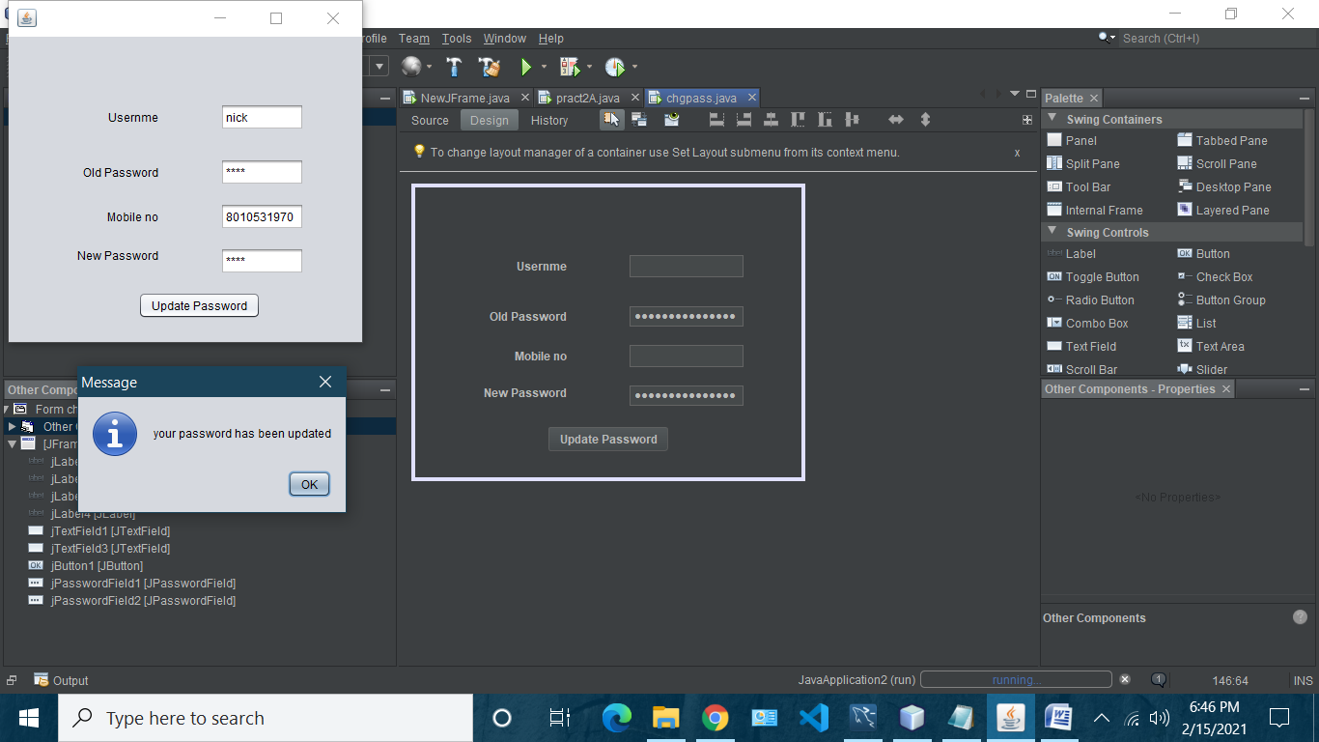

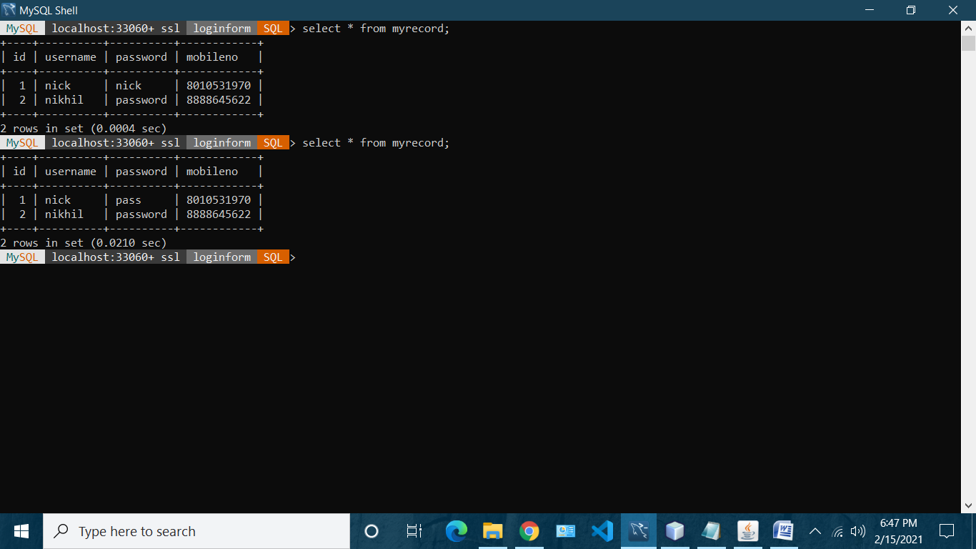

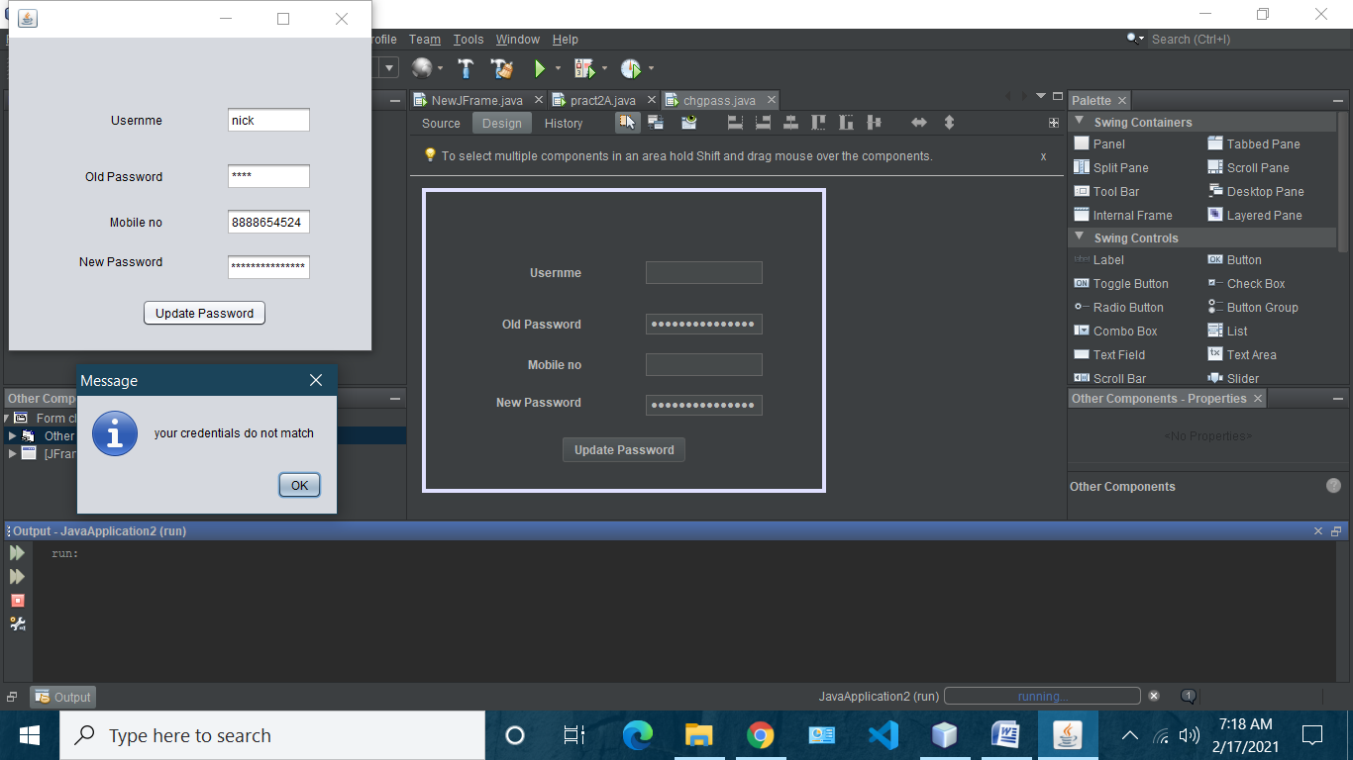

**Practical 3D: Delete Account**

import java.sql.Connection;

import java.sql.DriverManager;

import java.sql.ResultSet;

import java.sql.SQLException;

import java.sql.Statement;

import java.util.logging.Level;

import java.util.logging.Logger;

import javax.swing.JOptionPane;

/*

* To change this license header, choose License Headers in Project Properties.

* To change this template file, choose Tools | Templates

* and open the template in the editor.

*/

/**

*

* @author bot

*/

public class Pract2D extends javax.swing.JFrame {

/**

* Creates new form Pract2D

*/

public Pract2D() {

initComponents();

}

/**

* This method is called from within the constructor to initialize the form.

* WARNING: Do NOT modify this code. The content of this method is always

* regenerated by the Form Editor.

*/

@SuppressWarnings("unchecked")

// <editor-fold defaultstate="collapsed" desc="Generated Code">

private void initComponents() {

jLabel1 = new javax.swing.JLabel();

jLabel2 = new javax.swing.JLabel();

jLabel3 = new javax.swing.JLabel();

jTextField1 = new javax.swing.JTextField();

jTextField3 = new javax.swing.JTextField();

jButton1 = new javax.swing.JButton();

jPasswordField1 = new javax.swing.JPasswordField();

setDefaultCloseOperation(javax.swing.WindowConstants.EXIT_ON_CLOSE);

jLabel1.setText("Usernme");

jLabel2.setText("Password");

jLabel3.setText("Mobile no");

jTextField1.addActionListener(new java.awt.event.ActionListener() {

public void actionPerformed(java.awt.event.ActionEvent evt) {

jTextField1ActionPerformed(evt);

}

});

jButton1.setText("Delete record");

jButton1.addActionListener(new java.awt.event.ActionListener() {

public void actionPerformed(java.awt.event.ActionEvent evt) {

jButton1ActionPerformed(evt);

}

});

jPasswordField1.setText("jPasswordField1");

javax.swing.GroupLayout layout = new javax.swing.GroupLayout(getContentPane());

getContentPane().setLayout(layout);

layout.setHorizontalGroup(

layout.createParallelGroup(javax.swing.GroupLayout.Alignment.LEADING)

.addGroup(layout.createSequentialGroup()

.addGroup(layout.createParallelGroup(javax.swing.GroupLayout.Alignment.LEADING)

.addGroup(layout.createSequentialGroup()

.addGap(77, 77, 77)

.addGroup(layout.createParallelGroup(javax.swing.GroupLayout.Alignment.TRAILING)

.addComponent(jLabel3)

.addComponent(jLabel2)

.addComponent(jLabel1))

.addGap(64, 64, 64)

.addGroup(layout.createParallelGroup(javax.swing.GroupLayout.Alignment.LEADING, false)

.addComponent(jTextField1)

.addComponent(jTextField3)

.addComponent(jPasswordField1, javax.swing.GroupLayout.PREFERRED_SIZE, javax.swing.GroupLayout.DEFAULT_SIZE, javax.swing.GroupLayout.PREFERRED_SIZE)))

.addGroup(layout.createSequentialGroup()

.addGap(137, 137, 137)

.addComponent(jButton1)))

.addContainerGap(82, Short.MAX_VALUE))

);

layout.setVerticalGroup(

layout.createParallelGroup(javax.swing.GroupLayout.Alignment.LEADING)

.addGroup(layout.createSequentialGroup()

.addGap(69, 69, 69)

.addGroup(layout.createParallelGroup(javax.swing.GroupLayout.Alignment.BASELINE)

.addComponent(jTextField1, javax.swing.GroupLayout.PREFERRED_SIZE, javax.swing.GroupLayout.DEFAULT_SIZE, javax.swing.GroupLayout.PREFERRED_SIZE)

.addComponent(jLabel1))

.addGap(29, 29, 29)

.addGroup(layout.createParallelGroup(javax.swing.GroupLayout.Alignment.LEADING)

.addComponent(jPasswordField1, javax.swing.GroupLayout.PREFERRED_SIZE, javax.swing.GroupLayout.DEFAULT_SIZE, javax.swing.GroupLayout.PREFERRED_SIZE)

.addComponent(jLabel2))

.addGap(18, 18, 18)

.addGroup(layout.createParallelGroup(javax.swing.GroupLayout.Alignment.BASELINE)

.addComponent(jTextField3, javax.swing.GroupLayout.PREFERRED_SIZE, javax.swing.GroupLayout.DEFAULT_SIZE, javax.swing.GroupLayout.PREFERRED_SIZE)

.addComponent(jLabel3))

.addGap(36, 36, 36)

.addComponent(jButton1)

.addContainerGap(46, Short.MAX_VALUE))

);

pack();

}// </editor-fold>

private void jTextField1ActionPerformed(java.awt.event.ActionEvent evt) {

// TODO add your handling code here:

}

private void jButton1ActionPerformed(java.awt.event.ActionEvent evt) {

// TODO add your handling code here:

try {

String uname= jTextField1.getText();

String pass= String.valueOf(jPasswordField1.getPassword());

String mobileno= jTextField3.getText();

Connection conn=DriverManager.getConnection("jdbc:mysql://localhost:3306/loginform?autoReconnect=true&useSSL=false", "root", "root");

Statement stmt =conn.createStatement();

String sql= "select id from myrecord where username='"+ uname

+ "' and password ='"+pass+"' and mobileno='"+mobileno+"';";

ResultSet result=stmt.executeQuery(sql);

if(result.next()){

sql="Delete from myrecord where id='"+result.getInt(1)+"';";

stmt.executeUpdate(sql);

JOptionPane.showMessageDialog(this,"your Account has been Deleted");

}

else{

JOptionPane.showMessageDialog(this,"Record does not exist");

}

} catch (SQLException ex) {

Logger.getLogger(pract2A.class.getName()).log(Level.SEVERE, null, ex);

}

}

/**

* @param args the command line arguments

*/

public static void main(String args[]) {

/* Set the Nimbus look and feel */

//<editor-fold defaultstate="collapsed" desc=" Look and feel setting code (optional) ">

/* If Nimbus (introduced in Java SE 6) is not available, stay with the default look and feel.

* For details see http://download.oracle.com/javase/tutorial/uiswing/lookandfeel/plaf.html

*/

try {

for (javax.swing.UIManager.LookAndFeelInfo info : javax.swing.UIManager.getInstalledLookAndFeels()) {

if ("Nimbus".equals(info.getName())) {

javax.swing.UIManager.setLookAndFeel(info.getClassName());

break;

}

}

} catch (ClassNotFoundException ex) {

java.util.logging.Logger.getLogger(Pract2D.class.getName()).log(java.util.logging.Level.SEVERE, null, ex);

} catch (InstantiationException ex) {

java.util.logging.Logger.getLogger(Pract2D.class.getName()).log(java.util.logging.Level.SEVERE, null, ex);

} catch (IllegalAccessException ex) {

java.util.logging.Logger.getLogger(Pract2D.class.getName()).log(java.util.logging.Level.SEVERE, null, ex);

} catch (javax.swing.UnsupportedLookAndFeelException ex) {

java.util.logging.Logger.getLogger(Pract2D.class.getName()).log(java.util.logging.Level.SEVERE, null, ex);

}

//</editor-fold>

/* Create and display the form */

java.awt.EventQueue.invokeLater(new Runnable() {

public void run() {

new Pract2D().setVisible(true);

}

});

}

// Variables declaration - do not modify

private javax.swing.JButton jButton1;

private javax.swing.JLabel jLabel1;

private javax.swing.JLabel jLabel2;

private javax.swing.JLabel jLabel3;

private javax.swing.JPasswordField jPasswordField1;

private javax.swing.JTextField jTextField1;

private javax.swing.JTextField jTextField3;

// End of variables declaration

}

**Output:**

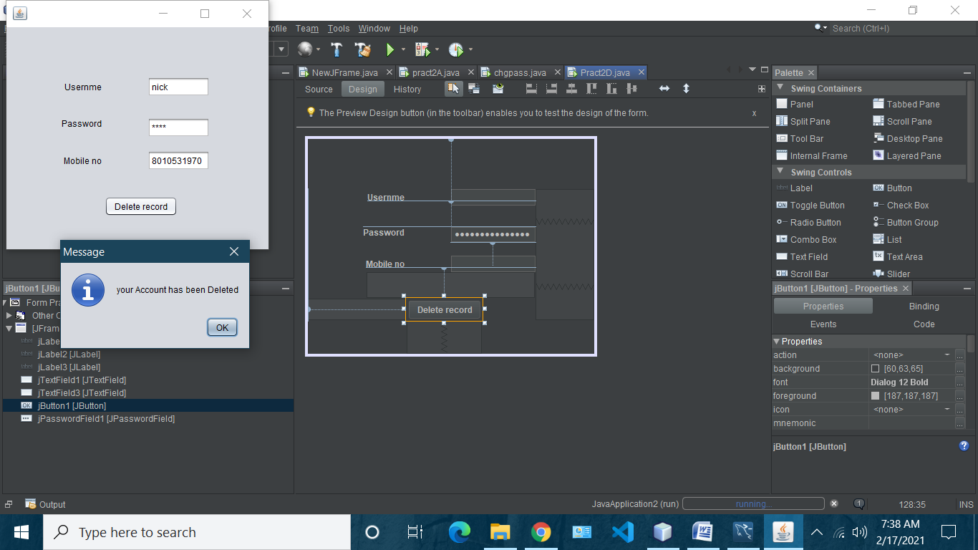

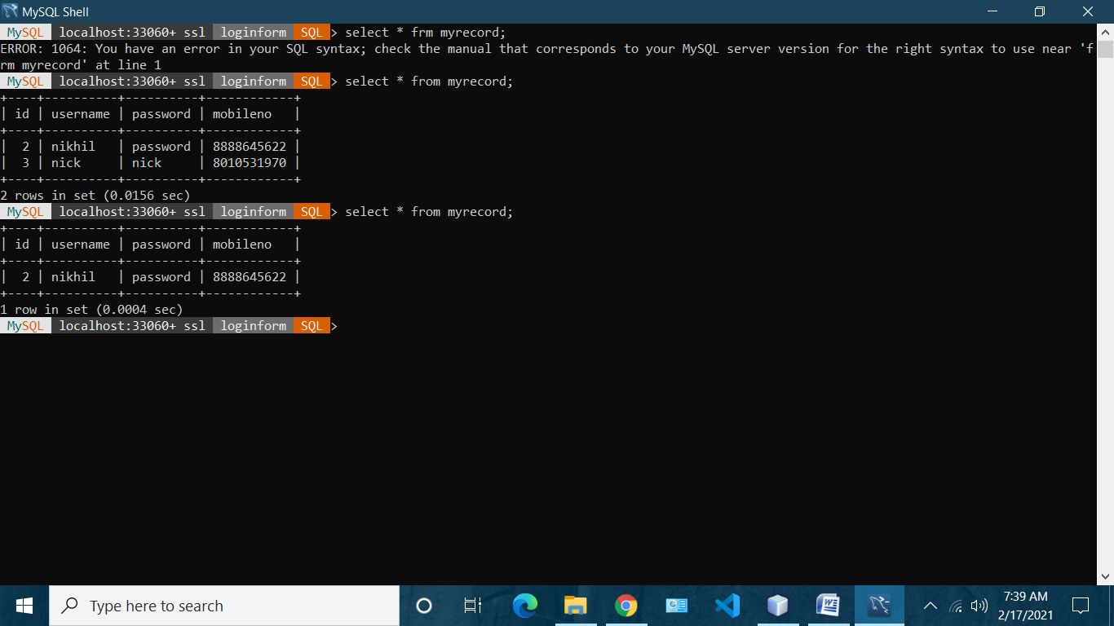

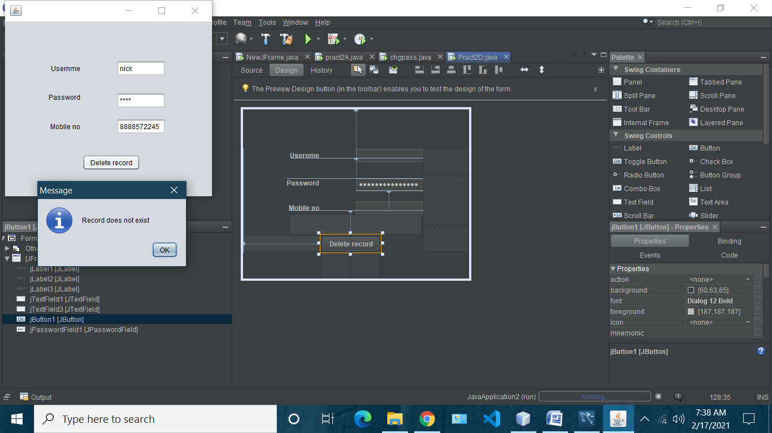

**Practical 3E**

Aim: Develop business logic layer for Library Management System.

**LibrarianDoa.java**

import java.sql.*;

public class LibrarianDao {

Connection con=null;

public static int save(String name,String password,String email,String address,String city,String contact){

int status=0;

try{

Class.forName("com.mysql.jdbc.Driver");

con=DriverManager.getConnection("jdbc:mysql://localhost:3306/test","",""); PreparedStatement ps=con.prepareStatement("insert into

librarian(name,password,email,address,city,contact) values(?,?,?,?,?,?)"); ps.setString(1,name);

ps.setString(2,password);

ps.setString(3,email);

ps.setString(4,address);

ps.setString(5,city);

ps.setString(6,contact);

status=ps.executeUpdate();

con.close();

}catch(Exception e){System.out.println(e);}

return status;

}

public static int delete(int id){

int status=0;

try{

Class.forName("com.mysql.jdbc.Driver");

con=DriverManager.getConnection("jdbc:mysql://localhost:3306/test","",""); PreparedStatement ps=con.prepareStatement("delete from librarian

where id=?");

ps.setInt(1,id);

status=ps.executeUpdate();

con.close();

}catch(Exception e){System.out.println(e);}

return status;

}

public static boolean validate(String name,String password){

boolean status=false;

try{

Connection con=DB.getConnection();

PreparedStatement ps=con.prepareStatement("select * from librarian

where name=? and password=?");

ps.setString(1,name);

ps.setString(2,password);

ResultSet rs=ps.executeQuery();

status=rs.next();

con.close();

}catch(Exception e){System.out.println(e);}

return status;

}

}

**LibrarianForm.java**

import java.awt.BorderLayout;

import java.awt.EventQueue;

import javax.swing.JFrame;

import javax.swing.JPanel;

import javax.swing.border.EmptyBorder;

import javax.swing.GroupLayout;

import javax.swing.GroupLayout.Alignment;

import javax.swing.JLabel;

import javax.swing.JOptionPane;

import java.awt.Font;

import java.awt.Color;

import javax.swing.JTextField;

import javax.swing.JPasswordField;

import javax.swing.LayoutStyle.ComponentPlacement; import javax.swing.JButton;

import java.awt.event.ActionListener;

import java.awt.event.ActionEvent;

public class LibrarianForm extends JFrame {

static LibrarianForm frame;

private JPanel contentPane;

private JTextField textField;

private JTextField textField_1;

private JTextField textField_2;

private JTextField textField_3;

private JTextField textField_4;

private JPasswordField passwordField;

/**

* Launch the application.

*/

public static void main(String[] args) {

EventQueue.invokeLater(new Runnable() {

public void run() {

try {

frame = new LibrarianForm();

frame.setVisible(true);

} catch (Exception e) {

e.printStackTrace();

}

}

});

}

/**

* Create the frame.

*/

public LibrarianForm() {

setDefaultCloseOperation(JFrame.EXIT_ON_CLOSE); setBounds(100, 100, 450, 450);

contentPane = new JPanel();

contentPane.setBorder(new EmptyBorder(5, 5, 5, 5));

setContentPane(contentPane);

JLabel lblAddLibrarian = new JLabel("Add Librarian"); lblAddLibrarian.setForeground(Color.DARK_GRAY); lblAddLibrarian.setFont(new Font("Tahoma", Font.PLAIN, 22));

JLabel lblName = new JLabel("Name:");

JLabel lblPassword = new JLabel("Password:");

JLabel lblEmail = new JLabel("Email:");

JLabel lblAddress = new JLabel("Address:");

JLabel lblCity = new JLabel("City:");

JLabel lblContactNo = new JLabel("Contact No:");

textField = new JTextField();

textField.setColumns(10);

textField_1 = new JTextField();

textField_1.setColumns(10);

textField_2 = new JTextField();

textField_2.setColumns(10);

textField_3 = new JTextField();

textField_3.setColumns(10);

textField_4 = new JTextField();

textField_4.setColumns(10);

passwordField = new JPasswordField();

JButton btnNewButton = new JButton("Add Librarian");

btnNewButton.addActionListener(new ActionListener() {

public void actionPerformed(ActionEvent e) {

String name=textField.getText();

String password=String.valueOf(passwordField.getPassword());

String email=textField_1.getText();

String address=textField_2.getText();

String city=textField_3.getText();

String contact=textField_4.getText();

int i=LibrarianDao.save(name, password, email, address, city, contact); if(i>0){

JOptionPane.showMessageDialog(LibrarianForm.this,"Librarian added successfully!");

AdminSuccess.main(new String[]{});

frame.dispose();

}else{

JOptionPane.showMessageDialog(LibrarianForm.this,"Sorry,

unable to save!");

}

}

});

btnNewButton.setForeground(Color.DARK_GRAY);

JButton btnBack = new JButton("Back");

btnBack.addActionListener(new ActionListener() {

public void actionPerformed(ActionEvent e) {

AdminSuccess.main(new String[]{});

frame.dispose();

}

});

GroupLayout gl_contentPane = new GroupLayout(contentPane);

gl_contentPane.setHorizontalGroup(

gl_contentPane.createParallelGroup(Alignment.TRAILING)

.addGroup(gl_contentPane.createSequentialGroup()

.addGap(20)

.addGroup(gl_contentPane.createParallelGroup(Alignment.LEADING, false) .addComponent(lblPassword,

GroupLayout.DEFAULT_SIZE, 62, Short.MAX_VALUE)

.addComponent(lblName)

.addComponent(lblEmail,

GroupLayout.PREFERRED_SIZE, 31, GroupLayout.PREFERRED_SIZE) .addComponent(lblAddress,

GroupLayout.DEFAULT_SIZE, GroupLayout.DEFAULT_SIZE, Short.MAX_VALUE) .addComponent(lblCity,

GroupLayout.PREFERRED_SIZE, 31, GroupLayout.PREFERRED_SIZE) .addComponent(lblContactNo,

GroupLayout.DEFAULT_SIZE, GroupLayout.DEFAULT_SIZE, Short.MAX_VALUE))

.addGap(58)

.addGroup(gl_contentPane.createParallelGroup(Alignment.LEADING, false) .addComponent(textField_4,

GroupLayout.DEFAULT_SIZE, 177, Short.MAX_VALUE)

.addComponent(textField_3,

GroupLayout.DEFAULT_SIZE, 177, Short.MAX_VALUE)

.addComponent(textField_2,

GroupLayout.DEFAULT_SIZE, 177, Short.MAX_VALUE)

.addComponent(textField_1,

GroupLayout.DEFAULT_SIZE, 177, Short.MAX_VALUE)

.addComponent(textField,

GroupLayout.DEFAULT_SIZE, 177, Short.MAX_VALUE)

.addComponent(passwordField))

.addContainerGap(107, Short.MAX_VALUE))

.addGroup(gl_contentPane.createSequentialGroup()

.addContainerGap(151, Short.MAX_VALUE)

.addComponent(lblAddLibrarian)

.addGap(144))

.addGroup(gl_contentPane.createSequentialGroup()

.addContainerGap(160, Short.MAX_VALUE)

.addComponent(btnNewButton,

GroupLayout.PREFERRED_SIZE, 131, GroupLayout.PREFERRED_SIZE) .addGap(133))

.addGroup(gl_contentPane.createSequentialGroup()

.addContainerGap(200, Short.MAX_VALUE)

.addComponent(btnBack)

.addGap(169))

);

gl_contentPane.setVerticalGroup(

gl_contentPane.createParallelGroup(Alignment.LEADING)

.addGroup(gl_contentPane.createSequentialGroup()

.addComponent(lblAddLibrarian)

.addGap(18)

.addGroup(gl_contentPane.createParallelGroup(Alignment.LEADING)

.addGroup(gl_contentPane.createSequentialGroup()

.addComponent(lblName)

.addGap(18)

.addComponent(lblPassword))

.addGroup(gl_contentPane.createSequentialGroup()

.addComponent(textField,

GroupLayout.PREFERRED_SIZE, GroupLayout.DEFAULT_SIZE, GroupLayout.PREFERRED_SIZE)

.addPreferredGap(ComponentPlacement.UNRELATED)

.addComponent(passwordField,

GroupLayout.PREFERRED_SIZE, GroupLayout.DEFAULT_SIZE, GroupLayout.PREFERRED_SIZE)))

.addGap(18)

.addGroup(gl_contentPane.createParallelGroup(Alignment.BASELINE) .addComponent(lblEmail)

.addComponent(textField_1,

GroupLayout.PREFERRED_SIZE, GroupLayout.DEFAULT_SIZE, GroupLayout.PREFERRED_SIZE))

.addGap(18)

.addGroup(gl_contentPane.createParallelGroup(Alignment.BASELINE) .addComponent(lblAddress)

.addComponent(textField_2,

GroupLayout.PREFERRED_SIZE, GroupLayout.DEFAULT_SIZE, GroupLayout.PREFERRED_SIZE))

.addGap(18)

.addGroup(gl_contentPane.createParallelGroup(Alignment.BASELINE) .addComponent(lblCity)

.addComponent(textField_3,

GroupLayout.PREFERRED_SIZE, GroupLayout.DEFAULT_SIZE, GroupLayout.PREFERRED_SIZE))

.addGap(18)

.addGroup(gl_contentPane.createParallelGroup(Alignment.BASELINE) .addComponent(lblContactNo)

.addComponent(textField_4,

GroupLayout.PREFERRED_SIZE, GroupLayout.DEFAULT_SIZE, GroupLayout.PREFERRED_SIZE))

.addGap(18)

.addComponent(btnNewButton,

GroupLayout.PREFERRED_SIZE, 36, GroupLayout.PREFERRED_SIZE) .addPreferredGap(ComponentPlacement.RELATED,

57, Short.MAX_VALUE)

.addComponent(btnBack)

.addGap(19))

);

contentPane.setLayout(gl_contentPane);

}

}

**ViewLibrarian.java**

import java.awt.BorderLayout;

import java.awt.EventQueue;

import java.sql.Connection;

import java.sql.PreparedStatement;

import java.sql.ResultSet;

import java.sql.ResultSetMetaData;

import javax.swing.JFrame;

import javax.swing.JPanel;

import javax.swing.JScrollPane;

import javax.swing.border.EmptyBorder;

import javax.swing.JTable;

public class ViewLibrarian extends JFrame {

private JPanel contentPane;

private JTable table;

public static void main(String[] args) {

EventQueue.invokeLater(new Runnable() {

public void run() {

try {

ViewLibrarian frame = new ViewLibrarian();

frame.setVisible(true);

} catch (Exception e) {

e.printStackTrace();

}

}

});

}

/**

* Create the frame.

*/

public ViewLibrarian() {

setDefaultCloseOperation(JFrame.HIDE_ON_CLOSE);

setBounds(100, 100, 450, 300);

contentPane = new JPanel();

contentPane.setBorder(new EmptyBorder(5, 5, 5, 5));

contentPane.setLayout(new BorderLayout(0, 0));

setContentPane(contentPane);

String data[][]=null;

String column[]=null;

try{

Connection con=DB.getConnection();

PreparedStatement ps=con.prepareStatement("select * from

librarian",ResultSet.TYPE_SCROLL_SENSITIVE,ResultSet.CONCUR_UPDATABLE); ResultSet rs=ps.executeQuery();

ResultSetMetaData rsmd=rs.getMetaData();

int cols=rsmd.getColumnCount();

column=new String[cols];

for(int i=1;i<=cols;i++){

column[i-1]=rsmd.getColumnName(i);

}

rs.last();

int rows=rs.getRow();

rs.beforeFirst();

data=new String[rows][cols];

int count=0;

while(rs.next()){

for(int i=1;i<=cols;i++){

data[count][i-1]=rs.getString(i);

}

count++;

}

con.close();

}catch(Exception e){System.out.println(e);}

table = new JTable(data,column);

JScrollPane sp=new JScrollPane(table);

contentPane.add(sp, BorderLayout.CENTER);

}

}

**DeleteLibrarian.java**

import java.awt.BorderLayout;

import java.awt.EventQueue;

import javax.swing.JFrame;

import javax.swing.JPanel;

import javax.swing.border.EmptyBorder;

import javax.swing.GroupLayout;

import javax.swing.GroupLayout.Alignment;

import javax.swing.JLabel;

import javax.swing.JOptionPane;

import javax.swing.JTextField;

import javax.swing.JButton;

import java.awt.Font;

import java.awt.event.ActionListener;

import java.awt.event.ActionEvent;

public class DeleteLibrarian extends JFrame {

static DeleteLibrarian frame;

private JPanel contentPane;

private JTextField textField;

/**

* Launch the application.

*/

public static void main(String[] args) {

EventQueue.invokeLater(new Runnable() {

public void run() {

try {

frame = new DeleteLibrarian();

frame.setVisible(true);

} catch (Exception e) {

e.printStackTrace();

}

}

});

}

/**

* Create the frame.

*/

public DeleteLibrarian() {

setDefaultCloseOperation(JFrame.EXIT_ON_CLOSE);

setBounds(100, 100, 450, 300);

contentPane = new JPanel();

contentPane.setBorder(new EmptyBorder(5, 5, 5, 5));

setContentPane(contentPane);

JLabel lblEnterId = new JLabel("Enter Id:");

textField = new JTextField();

textField.setColumns(10);

JButton btnDelete = new JButton("Delete");

btnDelete.addActionListener(new ActionListener() {

public void actionPerformed(ActionEvent e) {

String sid=textField.getText();

if(sid==null||sid.trim().equals("")){

JOptionPane.showMessageDialog(DeleteLibrarian.this,"Id can't be blank"); }else{

int id=Integer.parseInt(sid);

int i=LibrarianDao.delete(id);

if(i>0){

JOptionPane.showMessageDialog(DeleteLibrarian.this,"Record deleted successfully!");

}else{

JOptionPane.showMessageDialog(DeleteLibrarian.this,"Unable to delete given id!"); }

}

}

});

btnDelete.setFont(new Font("Tahoma", Font.PLAIN, 13));

JButton btnNewButton = new JButton("Back");

btnNewButton.addActionListener(new ActionListener() {

public void actionPerformed(ActionEvent e) {

AdminSuccess.main(new String[]{});

frame.dispose();

}

});

btnNewButton.setFont(new Font("Tahoma", Font.PLAIN, 13)); GroupLayout gl_contentPane = new GroupLayout(contentPane); gl_contentPane.setHorizontalGroup(

gl_contentPane.createParallelGroup(Alignment.LEADING)

.addGroup(gl_contentPane.createSequentialGroup()

.addGap(39)

.addComponent(lblEnterId)

.addGap(57)

.addComponent(textField,

GroupLayout.PREFERRED_SIZE, 178, GroupLayout.PREFERRED_SIZE) .addContainerGap(107, Short.MAX_VALUE))

.addGroup(Alignment.TRAILING,

gl_contentPane.createSequentialGroup()

.addContainerGap(175, Short.MAX_VALUE)

.addComponent(btnDelete,

GroupLayout.PREFERRED_SIZE, 109, GroupLayout.PREFERRED_SIZE) .addGap(140))

.addGroup(Alignment.TRAILING,

gl_contentPane.createSequentialGroup()

.addContainerGap(322, Short.MAX_VALUE)

.addComponent(btnNewButton,

GroupLayout.PREFERRED_SIZE, 92, GroupLayout.PREFERRED_SIZE) .addContainerGap())

);

gl_contentPane.setVerticalGroup(

gl_contentPane.createParallelGroup(Alignment.LEADING)

.addGroup(gl_contentPane.createSequentialGroup()

.addGap(19)

.addGroup(gl_contentPane.createParallelGroup(Alignment.LEADING) .addComponent(textField,

GroupLayout.PREFERRED_SIZE, GroupLayout.DEFAULT_SIZE, GroupLayout.PREFERRED_SIZE)

.addComponent(lblEnterId))

.addGap(33)

.addComponent(btnDelete,

GroupLayout.PREFERRED_SIZE, 33, GroupLayout.PREFERRED_SIZE) .addGap(43)

.addComponent(btnNewButton)

.addContainerGap(78, Short.MAX_VALUE))

);

contentPane.setLayout(gl_contentPane);

}

}

**Output**

**Admin Module after login**

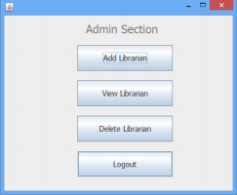**Add Librarian**

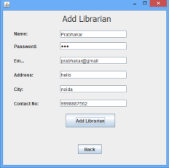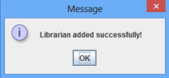

**View Librarian**

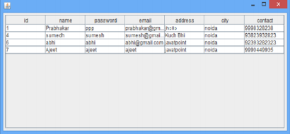**Delete Librarian**

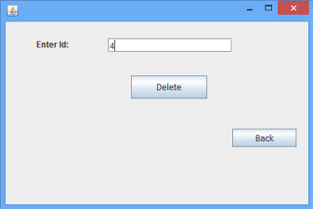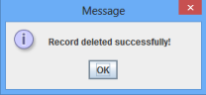

**Similarly we can inculcate book management and Librarian update functionalities in the Librarian module.**